Dough Expert C
Next generation DOUGH EXPERT divider designed and produced by Benier

- 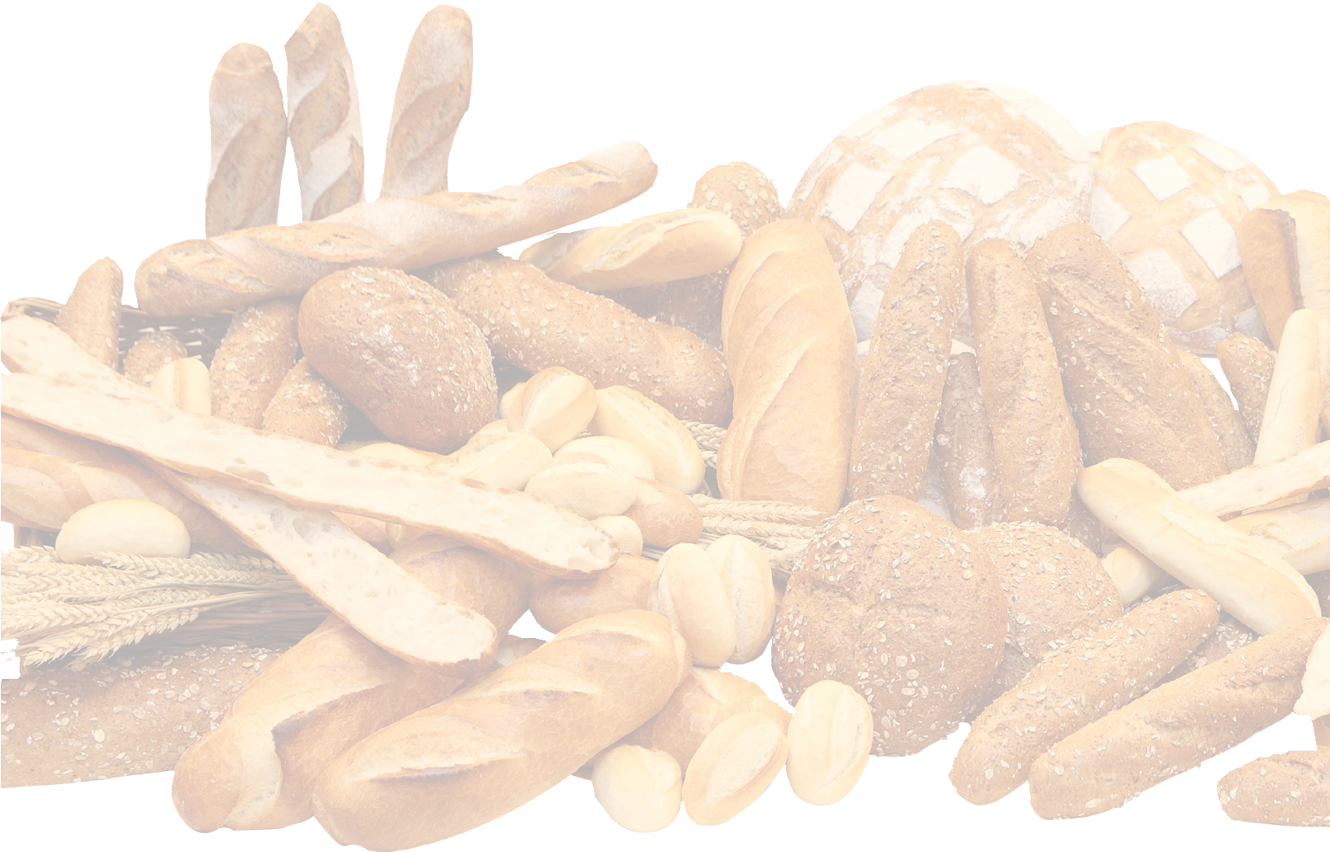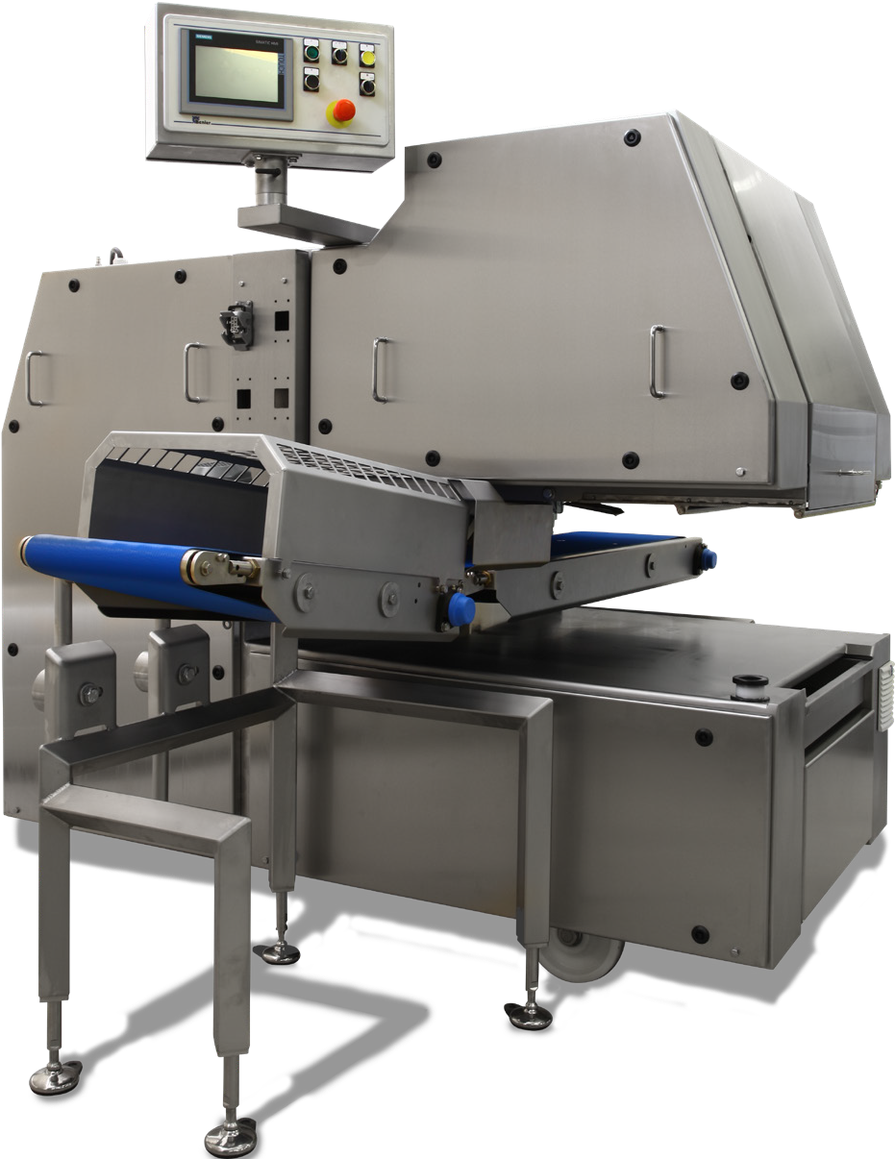Universal pocket divider
The Dough Expert C is universally applicable and is suitable for a wide range of dough processes, capacities and weight ranges because of its industrial design.

- Robustness, reliability and accuracy
Characteristic features of the Dough Expert family: high level of reliability, accuracy and flexibility.

- Easy to clean:
  - Excellent accessibility of the machine because of the C-frame
  - The conveyor can be rolled in and out of place
  - The conveyors have a quick release construction to ensure easy access
  - Springs and/ or pneumatic cylinders are completely enclosed in a housing to prevent dough pollution
  - The dividing area, the dough zone, can be hosed down

- Wide range of pocket configurations
Based on weight range, capacity and dough type the dividing box will be configured.

Ka a k F P S | Ka a k B a k e w a r e | B e n i e r | D r i e M | D a u b | M C S | L h o t e l l i e r R 2 A | M u l t i p a r t s

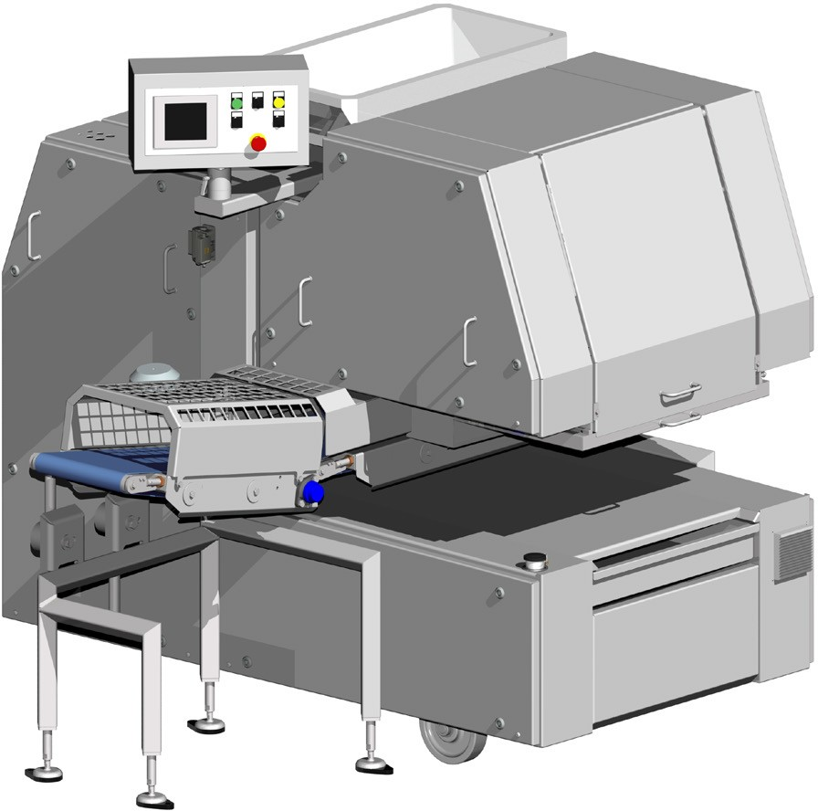
Height: 1679 mm.

 |  | Weight range (gr)* |  | Capacity (pcs/hr)**
Type | Pockets | Min. | Max. | Min. | Max.
DE 20 | 2 | 400 | 2.150 | 750 | 3.200
DE 24 | 2 | 400 | 2.150 | 750 | 3.200
 | 4 | 190 | 1.025 | 1.500 | 6.400
DE 30 | 3 | 250 | 1.400 | 1.125 | 4.800
DE36 | 3 | 250 | 1.400 | 1.125 | 4.800
 | 6 | 115 | 645 | 2.250 | 9.600
DE 40 | 4 | 190 | 1.025 | 1.500 | 6.400
DE 50 | 5 | 140 | 800 | 1.875 | 8.000
DE 60 | 6 | 115 | 645 | 2.250 | 9.600
DE WB 30 | 3 | 320 | 1.875 | 1.125 | 4.800
DE WB 36 | 3 | 320 | 1.875 | 1.125 | 4.800
 | 6 | 150 | 880 | 2.250 | 9.600
DE WB 40 | 4 | 230 | 1.380 | 1.500 | 6.400
DE WB 48 | 4 | 230 | 1.380 | 1.500 | 6.400
 | 8 | 105 | 630 | 3.000 | 12.800
DE WB 50 | 5 | 180 | 1.075 | 1.875 | 8.000
DE WB 60 | 6 | 150 | 880 | 2.250 | 9.600
DE WB 80 | 8 | 105 | 630 | 3.000 | 12.800

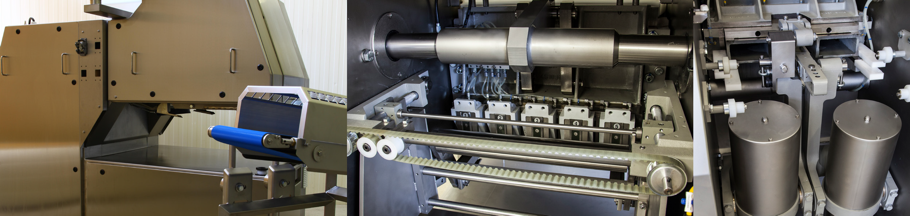Benier Nederland b.v., Looier 20, 5253 RA Nieuwkuijk, P.O. Box 95, 5250 AB Vlijmen, The Netherlands
Features
- A real “work-horse” with outstanding track record
- Fully integrated PLC to support the operator
- Modular design; easy to configure to the process requests
- Hygienic, easy to clean design
* Weight range is related to density of the dough
** Capacity is related to dough consistency, required dividing accuracy, dough weight and required final structure of end product.
Main piston and knife
Dividing chamber
Roll in - Roll out
Easy to clean and maintain
T +31 (0)73 6150 500, F +31 (0)73 6150 501, E info@benier.nl, www.benier.com Member of the

