1 2 3 4 5 6

Rev/ Ch anges
eco

Da te

'\()
'\()
L.f)
...,,...
::\ \\\
\ \ ·.
\ ....,...

')'.,.

.··...
··...
@ Air p = 6 BAR

',
01/ ISIEMENSFrame I 2013
01- 31

·
[±] M 1(
u
- I A
1
/
I

:••:;
  - 1vrf1
1·:l).D: ( '
discharge lef t '
0

•O + • n
L ..J .... ...L....
['... o
i - .-i.

n m = L= ,
: 1 :=-i-t-- =:i :. - - )-"1'9
['... 7

l...Li
";'
" ...l...

LL://:

,;-
L ! - - ,t +-
-1-
H ' 2_.J L -- ·- -Ll-
·- -
o rn1- +·- ·- - - -
, ,1
1-.
17 - 1 - -.=I=- - -

- _J-·
- _J

discharge left
discharge right
n
I I
LJ

''•.
n

..· ,·•

CJ\
'\()

- Oil

'\()
'\()
L.f)
· ·.··...
/ ·.·•., .,....... .>

.

B

/ "",'""<'<

400 662
>:::. \ T ··.···

720 1
!
e'Jl!jlii) o ll

'- J-j

- /•::
r
B

";,(·.. ,,',,/f;>: )> ,::::..-\ \
/ rf:,..:··.. .-f,_.j 1, ,::/

\ ··•.::··.. \ / )·:.,-::.:·_•,.. 0
CD
(,)
I
\ I
.

\ •,-\ ·' ...... ;
\ <: ::: ::·.·:
.
. ..·.·<· ·n·:>...-
.........
\

0
['...
-'­,
r-
0
0
,;-
+
-' :.I-r-'
1 i
-- - - -- - -
r
7
I
: il . •......>I i-,· p :....- 1.
L i
(,)
VI
I r-
7

t 1 01
0so
,
-!-•- ·-
, · ;.r_{.J}-.-..-f-Ei -
- _- _
_; _; ;) ffi
,;-

,;-
0
i 0
N
,;-
C
C
.O,_J
...c.
r-.._
- 't- Q_- - - - - - [ _)
"·"·
l- - - -
'\()

C ' i
01 (,) I\ J_ "· " ·"· C

i OJ
(,) 0 . "·

[ i J
_ j_
G
' '-.J
-- J

...c.
I'--- t..n' "·" ·
□ '
'-.J J

694
(,)
1770 '\()
950
490
L 936
1770
-

1121

FOR APPROVAL
BENIER NEDER LA ND B.V.
FOR APPROVAL CUSTOMER

64 L. 120 L. SIGNATURE: DA TE: DATE: DATE:
r
,rI
r

400
JT

D
720
1
' \
1..
..-i '
1
614 sos
·v· 1
837
1
·· .....i .... D

DIMENSIONS IN MM
DERIV ATED FROM: REFERENCE:

... ·· d
r
66 as
(,)
·········,

l @
·· ·· ·1 · ·· ·· ·· ·· ·· · ·· , · ·· ··
.. ... :........ .......: ... . -E3
AM. PROJ.
0
0
N

DRAWN BY: DA TE: DESCRIP TION:
F. L ee 2006-06-28

i! i . _J_
!

..... ........ ......; ...

...... . .......... . ....... . ... ....... . ...... . ... . .....
,;-
'Th-is port stls,teand all data conlanedelhereh.rare
exclusive prcpe-ly cf BENE R P'EDERI..AN) BV , issued in strict confidence and net be reproduced. copied Of used for any ps pcse whatsoever without writt en permission of BEl'ER NEDERI..Mf) BV.
CHECKED BY: DATE : Dough Expert Ba sic L- R
SCALE: CODE: 99305003 REV.: 01
A2

1:20

1 2 3 4 5 6

1 2 3 4 5 6

Rev Ch anges
eco

Dote

, .. .
·

A

2-

'L°n

I
+--- - - - - - - - - - - ....---.-/

)x(
LJ

@ Air p = 6 BAR
Ii
SIEMENS Frame
2013
01- 30

A

g Ji:i

--

c::m]]
.....:. ..:.1.:
--
dis c h a r g e lef t '

-
L 3N ~ 400V - 50Hz + @
/ P = 5k W

dis charge lef t dis c h a r g e right fl
1
Sp ec ia l , C a n a di a n n etw or k:
L 3N ~ 575V - 60 Hz +@
/ P = 5k W
LJ + I

-

Oil
'L°n

- B

40 66 72

. . I

!
I
- . I
$ $ $$ \ I
□
nl ,_

iR
il
// I
CD $ 0 $
(Y')
' (
'x --

0
1 , ( Ji, il
- 1--q'-'
, ,\

\ ! OS r
0
s;-
'-
I
I
j
i + '-t

'-t
+
r----..
I
Ol '

_ I_ _!_
I
's;°-

s;- 0 c:: I '
c::
N
s;-
QJ
'°
-+--
' ...c::: 0\
C C
Ol (Y')
  - - r----..
...c:::
QJ
-.
-- J I I ,- -
lJJ V

6 9 L 95 49
177 '° 93
112
177
1905 with d ough pr es sur e comp en sa t o

64 L. 120 L .

400r662 0 720 614 505 r837
,r -r
·v
0
0
N
s;-

I

FOR APPR OVA L
BENIER NEDER L AND B. V.

SIGNA TURE:

FOR APPROVAL CUSTOMER

DATE : DATE : DATE:

CD
w
(Y')
D '
- 1 - 1
-1
1 ' i D
© CJ

D '\ J j'
DIMENSIONS IN MM DERIV ATED FROM: REFER ENCE:
9930162S

AM. PROJ.
"
0
0
N
DRAWN B Y: DAT E: DESCRIP TION:
F. Lee 2006- 06- 27
■

s;-
l
n1 r CH ECKED BY: DAT E: Dough Exp ert L-R

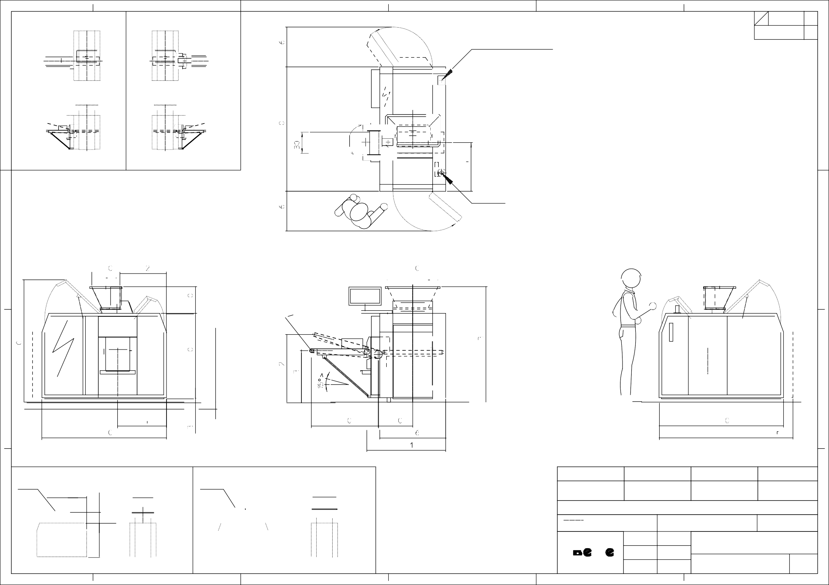
This portslisl. and all data contained !herein . are
exclus ive prop)er t y o f BENIER /'EOE RLANO a, v
issue d ii st ric t c on fidence and n o t be r epr oduced,
copied or used for any pu-posew halsoe ver without
writ ten permission of BENE R NEDERLAN) BV.
1 2 3 4 5
SCAL E:
1:20
A 2 CODE : 99305000
6
REV.: 01

