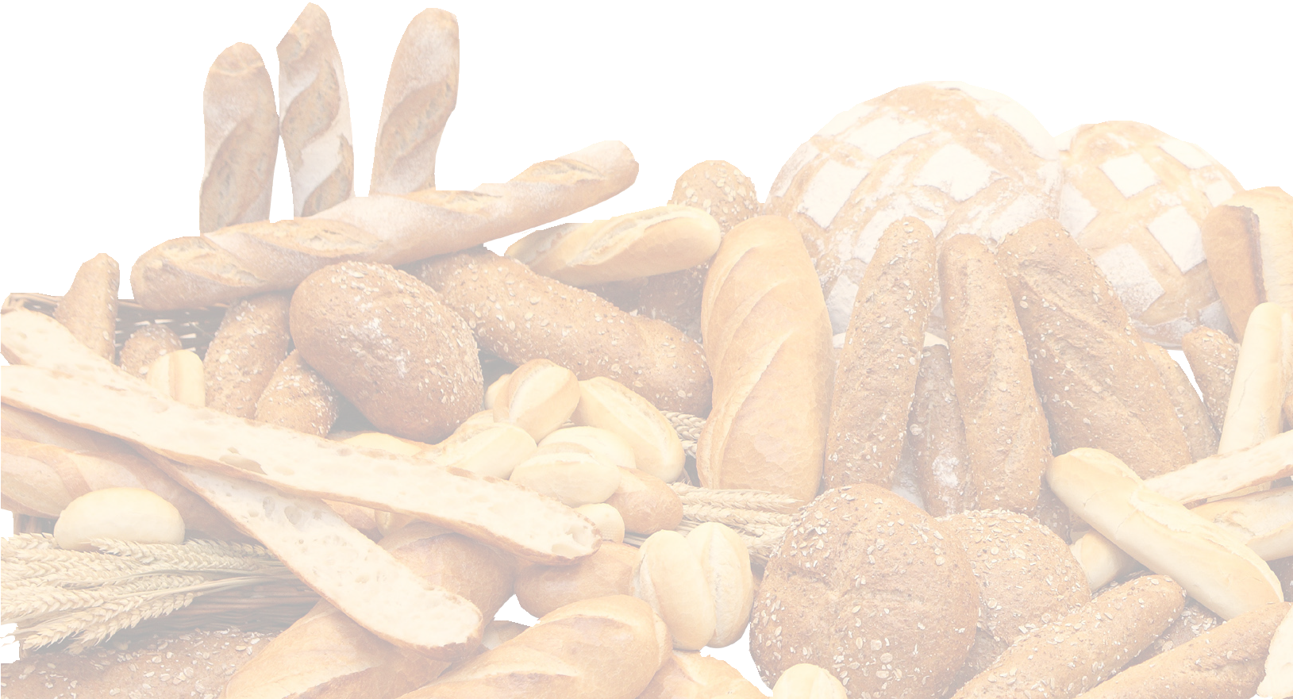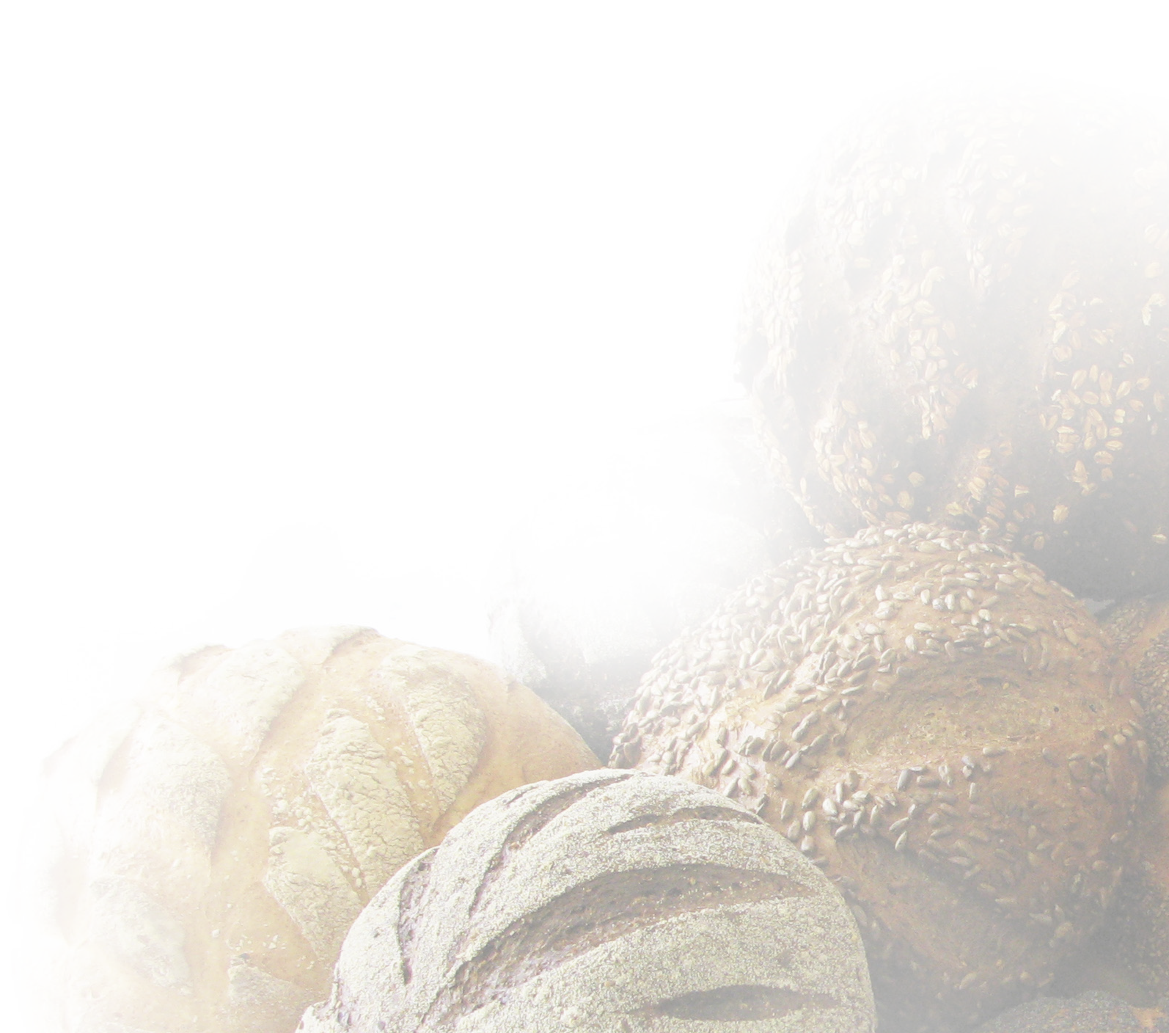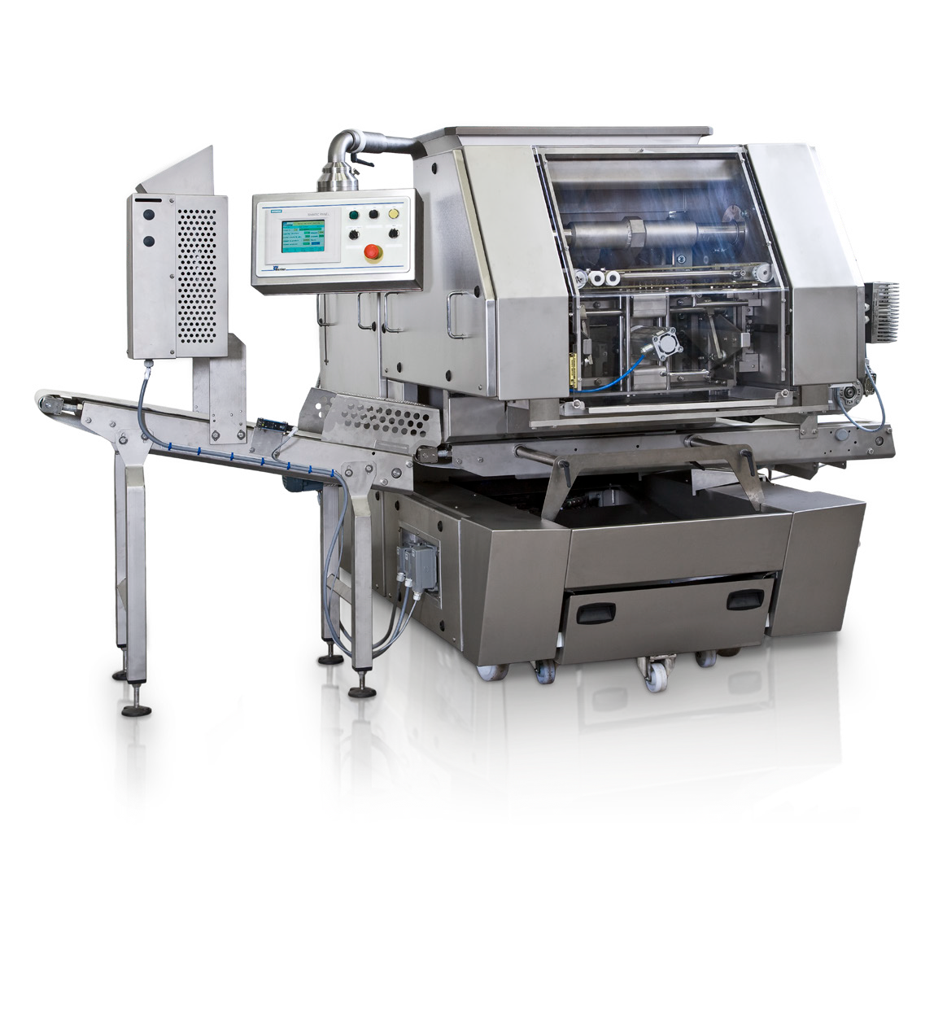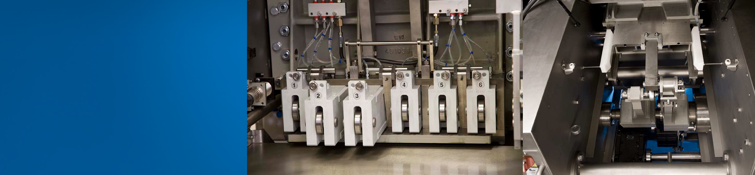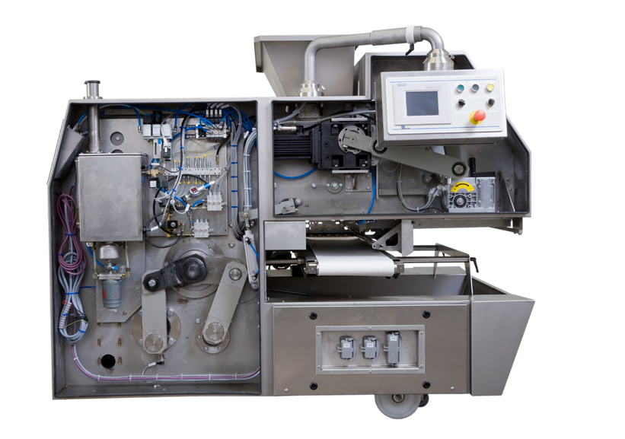Dough Master

The master of dough dividing designed and produced by Benier

By controlling the stress in the dough, various dough consistencies can be precisely processed to meet your quality standards and desired line efficiencies. Handling with care allows a higher water absorption without creating a stickier dough surface.

The Dough Related Software (DRS) manages the divider servo drives settings so even very delicate dough, with long fermentation times and high water content can be processed as gently as by hand. In combination with the Benier Dough Controller the total dividing process is optimized.

On-board intelligence
Synthetic dividing pistons
Heart of the divider

Ka a k F P S | Ka a k B a k e w a r e | B e n i e r | D r i e M | D a u b | M C S | L h o t e l l i e r R 2 A | M u l t i p a r t s

Features

Servo-controlled dividing process
- Reduction of rinse effect;
- Stress-free dividing; less dough damage;
- Optimisation of dough input and output; less residual dough;
- Higher water percentage without resulting in stickier dough.

Easy to clean
- Quick release concept;
- Open frame for easy access to the conveyors;
- Cleaning trolley to remove the knife and main piston easily from the machine.
- Hose down washable
- Conveyors have their own frame

Technical specifications

300

Easy to operate
- PLC and touch screen for control and operation;
- Easy to adapt to your requirements;
- Easy to integrate in the process;
- Available in various pocket configurations.

High weight accuracy
- The integrated Dough Related Software (DRS) and the Multi Pocket Design guarantee the highest achievable divider accuracy.

1100
732

1975
Type | Number | Weight range (gr)* |  | Capacity (pc/hr)**
 |  | min. | max. | max.
Dough Master
DM 20 | 2 | 420 | 2.270 | 3.200
DM 24 | 2 | 420 | 2.270 | 3.200
 | 4 | 190 | 1.075 | 6.400
DM 30 | 3 | 265 | 1.475 | 4.800
DM 36 | 3 | 265 | 1.475 | 4.800
 | 6 | 100 | 680 | 9.600
DM 40 | 4 | 200 | 1.080 | 6.400
DM 50 | 5 | 170 | 840 | 8.000
DM 60 | 6 | 100 | 680 | 9.600
Dough Master Wide Body
DM WB 30 | 3 | 320 | 1.875 | 4.800
DM WB 36 | 3 | 320 | 1.875 | 4.800
 | 6 | 150 | 880 | 9.600
DM WB 40 | 4 | 230 | 1.380 | 6.400
DM WB 48 | 4 | 230 | 1.380 | 6.400
 | 8 | 105 | 630 | 12.800
DM WB 50 | 5 | 180 | 1.075 | 8.000
DM WB 60 | 6 | 150 | 880 | 9.600
DM WB 80 | 8 | 105 | 630 | 12.800
Dough Master Super Wide Body
DM SWB 60 | 6 | 180 | 1.010 | 9.600
DM SWB 6/12 | 6 | 150 | 800 | 9.600
 | 12 | 70 | 360 | 19.200

719
1645

666
698 400

* Weight range is related to density of the dough
710
1385
** Capacity is related to dough consistency, required dividing accuracy, weight of dough piece and required final structure of the end product

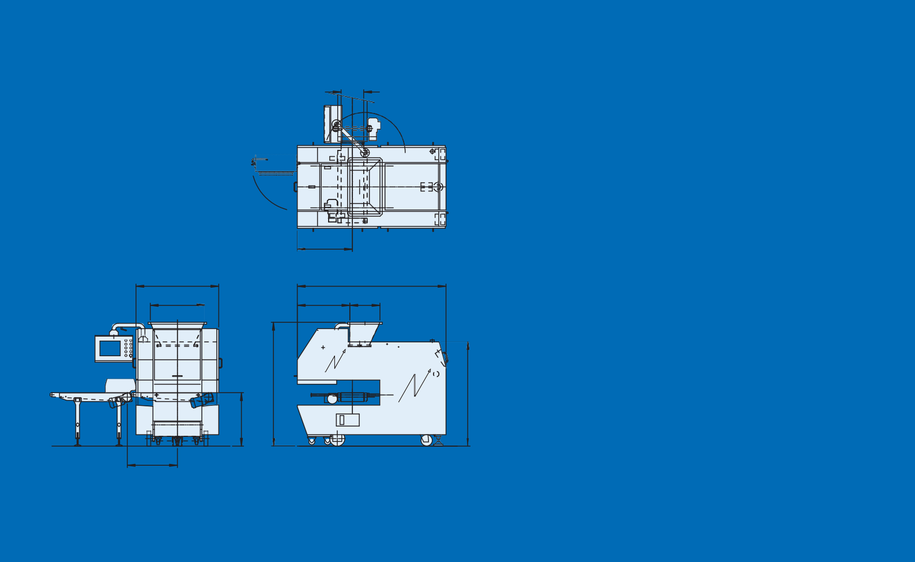

Benier Nederland b.v., Looier 20, 5253 RA Nieuwkuijk, P.O. Box 95, 5250 AB Vlijmen, The Netherlands
T +31 (0)73 6150 500, F +31 (0)73 6150 501, E info@benier.nl, www.benier.com Member of the

